Claims screen changes to handle workflow -

New field –

Bus Captain at fault = Yes/No

If No – only OD Assignment

If Yes – OD Assignment and TP Assignment

Button “Assignment” will display Claims Officer Duty Roster

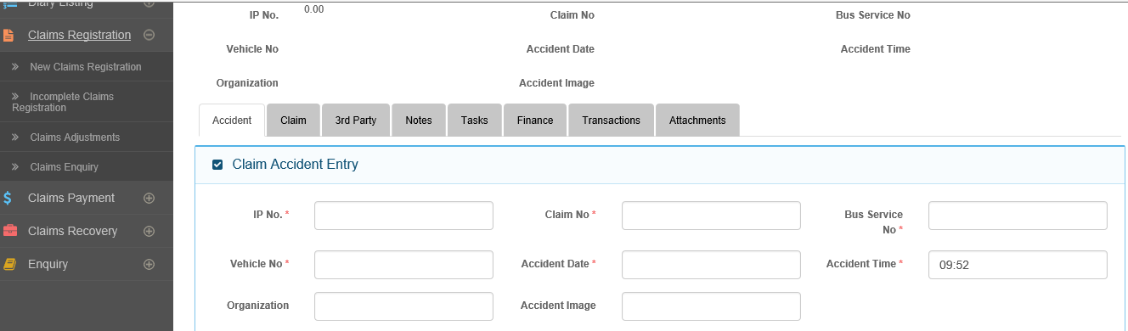

New Field –

TP Assignment – link to Duty Roster in Admin Module

New Field –

OD Assignment – link to Duty Roster in Admin Module

Notification process –

In CDGI, the Support Officer receives claims notification and then assign work to the Claims Officers based on a pre-set duty roster.

No

Assign OD Claims Officer

Bus Captain at fault?

Notification received

Yes

Assign OD Claims and TP Claims Officer

Upon saving the claim, the system will generate a Temporary Claim Number.

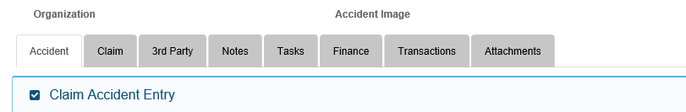

New Tab -Workflow

Diary

Escalation

Click on Escalation, the section on escalation table will appear

Click on Diary, the below table will appear

**Diary**

|  |  |  |  |  |  |  |  |
| --- | --- | --- | --- | --- | --- | --- | --- |
| S/N | Diary description | Action By | Action/Assignment | Completion Date | Completed Date | Reminder before Completion Date(Days) | Escalation |
| 1 | Claims Notification received, Bus Captain(BC) at fault? Yes/No | Support Officer | Assign to Claims Officer (CO) based on Duty Roster  Action –  Edit & Save | dd/mm/yyyy  Action –  Edit & Save | dd/mm/yyyy | 2 | Y/N, if Y, field available  Action –  Edit & Save |
|  | FOR S/N 2 – 37, see Diary Set-up from CDGI Workflow |  |  |  |  |  |  |

1. The Diary workflow is a fixed template, tabulating the standardized workflow of each claim. The workflow was derived from the workflow presented by CDGI, marking out points where reminder/assignment actions occur. For each Diary Description to be tabulated, see Diary Description column in Diary Set up from CDGI Workflow below.
2. Diary Description = action points.
3. Rectangle box – drop down selection by user updating this.--> Claims Handler Type --🡪User Names for selection

Display Users of handler type for selection

Claims Handler Type

* 1. Once user name selected, displayed in field

1. Action/Assignment – Support Officer will then assignment/action a Claims handler to handle the action. Same process as c.(a) above. However, this assignment is editable as the assigned staff may change due to inavailability. The circle button = View History – allow user to view changes made. Once assigned, email notification to person, indicating the Claims reference number and Action description
2. Completion date – this sets the action completion date. This can be editable and view history on changes made
3. Completed Date – the assigned person handling the task will update this field. The user can also escalate the action upwards by completion the escalation column.
4. The Reminder – this is to send an email reminder to the staff tasked but Completion Date is still blank.
5. Escalation – if Y, then the rectangle field appear for escalation action to the Claims Handler Type. Also editable and can view history

**Diary Set – up from CDGI Workflow**

|  |  |  |  |  |  |  |  |  |
| --- | --- | --- | --- | --- | --- | --- | --- | --- |
| S/N | Notification description | Action By | Action | Action tracked in MCAS | Expiry Date to Act | Reminder before expiry of action date - days |  |  |
| 1 | Claims Notification received, Bus Captain(BC) at fault? Yes/No | SP = Support Officer | Assign to Claims Officer (CO) based on Duty Roster | Register the Claim |  | 2 |  |  |
| 2 |  |  |  |  |  |  |  |  |
|  |  |  |  |  |  |  |  |  |
|  |  |  |  |  |  |  |  |  |
|  |  |  |  |  |  |  |  |  |

|  |  |  |  |  |  |  |  |  |  |
| --- | --- | --- | --- | --- | --- | --- | --- | --- | --- |
| S/N | Recovery Claims Actions | Action By | Action | Action tracked in MCAS | Expiry Date to Act | Reminder before expiry of action date - days | Status Update | Escalate to | When |
| 3 | Documents Received from workshops/district/safety to initiate recovery? | SP = Supervisor | Send reminder to workshop/district/safety | Trigger reminder | Default to date sent(system date?) + 7 days, incl of weekends/holidays | 2 | manual | SV | 3 months from Reminder date? |
| 4 | Recovery action assignment | SP = Supervisor | Assign to Claims Officer (CO) | How does the system gets updated CO has acted? |  | 2 |  |  |  |
| 5 | Recovery – LOD sent | CO | Send LOD | Provide field to enter date LOD sent | CO to set expiry date | 2 | manual |  |  |
| 6 - 9 | Set case review date | CO | Case review date update | CO enters or updates review date field and Remarks box, if any | N/A | 2 days from review date |  |  |  |
| 10 - 12 | Case Settled | CO | CO updates Case Settled | CO updates case settled status, settlement details in Remarks and follow up date and Expected Payment date | CO to set follow up date | 2 days from follow up date.  If expected settlement details not updated, send reminder to CO and SP, 2 days from expected Payment date | manual |  |  |
| 14 | Case settled – Payment received | CO | Update recovery amount in MCAS | Data entry for recovery received details – like chq No. etc |  |  |  |  |  |

|  |  |  |  |  |  |  |  |
| --- | --- | --- | --- | --- | --- | --- | --- |
| S/N | Third Party Property and Injury Claims |  |  |  |  |  |  |
| 15 - 16 | Assignment of claims action | SP | Assign to CO – provide for drop down lists of CO | How does the system gets updated CO has acted? |  | 2 |  |
| 17 - 18 | For Property and Injury Claims claim amount >15k | Who initiates? | SV (Supervisor) | To update field if Insurer taking over. If YES, process ends.  If No, update field Mandate Received | What is the turnaround? | 2 |  |
| 19 - 20 | Update Case Development |  |  |  |  |  |  |
| 21 – 22, 24, 26 - 28 | Review | CO | Updates review date | Set new review date, updates Remarks with any developments | Review date set | 2 |  |
| 23 | Writ of Summons issued | CO | Update Lawyer appointment | Selection of Lawyer from Admin |  |  |  |
| 25 | Case settled without Payment | CO | Update settlement details as No Payment | Updated field |  | 2 |  |
| 29 | Case resolved. Payment required | CO | Update settlement details in Remarks and set review date for payment due | Update field | Date set | 2 |  |
| 30 - 31 | Total payment >15k | CO | SV for approval to issue Debit Note for amount excess of 15k | Update field | Date set | 2 |  |
| 32 - 33 | Debit Note Approved by SV | CO | Inform Insurer and update expected Payment date | Update field | Expected Payment date | 2 |  |
| 34 - 35 | Payment processing | SP – process payments | SV – for approval and update expected approval received date | Update field | Expected approval date | 2 |  |
| 36 | Payment settlement | SP – process document for SBST Finance | CO – update expected payment date | Update field | Expected payment date field | 2 |  |
| 37 | Update payments details from SBST Finance | ? who process | CO – reminder for? |  |  |  |  |
|  |  |  |  |  |  |  |  |

**Diary Process – as per CDGI Workflow provided**

1. BC(Bus Captain) not at fault. SP to assign case to CO according to Duty Roster. Task initiated for CO with expiry date set. Send Reminder 2 days before task expires.
   1. What doc forms did the SP receive to create this flow
   2. What action in MCAS to confirm that CO has acted and reminder not triggered?
   3. What is the basis used for assigning OD to Cos – CO name sequence?
   4. Definition of 2 days – if date = 17th, then, 2 days before is 15th? That is, date set less 2?
   5. What is the role of SP in the whole claims process for OD, TP and Recovery
2. BC at fault. Third Party Claim. SP to assign third party case to CO according to Duty Roster. Task initiated for CO with expiry date set. Send Reminder 2 days before task expires.
   1. 2 Cos working on the same case?
   2. Can TP CO view OD claims data?
   3. What is the basis used for assigning TP to Cos?
3. Recovery Claim. Documents not received. Request documents from workshop / districts / safety. Task initiated for SP to send reminder to workshops / districts / safety with expiry date set (1 week). Send reminder 2 days before task expires
   1. How to initiate this reminder – destination and communication details?
   2. 1 week = 7 days from system date, inclusive of weekends and public holidays?

4. Recovery Claim. SP to assign cases to CO after documents received. CO notified of case. To Send LOD. Task initiated for CO with expiry date set. Send reminder 2 days before task expires

5. LOD Sent. Update Case Development. Task initiated for CO with expiry date set. Send reminder 2 days before task expires.

a. Provide field in Recovery screen?

6. CO to set custom date or allow system to set the date to review the case. Send Reminder to CO on the Date Set or default date of X days to review case

a. Recovery action cases for review?? Check flow with Dexter – same 7-10

b. new field for CO to enter case review date plus Remarks box to capture continuous notes for Case development – this review date could be re-set again, provide this re-update action

7. Review Case. Task initiated for CO with expiry date set. Send reminder 2 days before task expires.

8. Case Reviewed. Update Case Development. Task initiated for CO with expiry date set. Send reminder 2 days before task expires.

9. CO updates the development of the case and to set the custom date or allow system to set the date to review the case. Send Reminder to CO on the date set or default date of X days to review case.

10. Case Settled. No Lawyer appointed. To Update Case Development. Task initiated for CO with expiry date set. Send Reminder 2 days before task expires.

a. field for CO to update Case Settled = Yes and Remarks box for details.

b. field to enter follow-up date

c. reminder is for receiving of settlement amount?

11. Case Not Settled. No Litigation. Review Case. Task initiated for CO with expiry date set. Send reminder 2 days before task expires.

A. updates follow up date

b. Case settled – still outstanding

12. No Payment received. Claim Officer will be notified of outstanding payment. CO to set expected payment date. Send Reminder to CO on date set.

a. new field – Expected Payment Date and track work flow with this date

13. Still No Payment Received. CO & SP will be notified of the outstanding payment. Task initiated for CO to follow up on case. Send Reminder 2 days before task expires.

14. Payment received. Update Case Development. Task initiated for CO with expiry date set. Send Reminder 2 days before task expires.

a. what is this reminder for?

15. Third Party Property & Injury Claims. Task initiated for CO with expiry date set. Send Reminder 2 days before task expires.

16. Property Claim. Task initiated for CO with expiry date set. Send reminder 2 days before task expires.

17. Property Claim. Mandate required. Case forwarded to SV for Mandate. Task initiated for SV with expiry date set. Send reminder 2 days before task expires.

1. Who initiates the assignment to SV
2. What is Mandate and how to reflect this in MCAS? Mandatory field, Mandate Received = Yes
3. Tasks Response date to enter

18. Injury Claim. Claim less than $15k. No Insurer taking over conduct of claim. Mandate required. Case forwarded to SV for Mandate. Task initiated for SV with expiry date set. Send reminder 2 days before task expires. If insurer takes over claim, then, process ends

19. (Property / Injury Claim) Mandate given. Update Case Development. Task initiated for CO with expiry date set. Send reminder 2 days before task expiries.

a. what is this reminder task on? Update case development?

b. who initiates this task and how is expiry date set- OR should this be a review date setting? How does the system differentiate between Case development and Review?

20. (Property / Injury Claim) Mandate given. CO updates the development of the case and set Custom Date or allow system to set the date to review case. Send Reminder to CO on the date set or default date of X days to review case.

21. Review Case. Task initiated for CO with expiry date set. Send Reminder 2 days before task expires.

22. Case Reviewed. To update Case Development. Task initiated for CO with expiry date set. Send Reminder 2 days before task expires.

23. No Payment Required. Case not settled. Writ of Summon issued. To Appoint Lawyer. Task initiated for CO with expiry date set. Send Reminder 2 days before task expires.

a. who initiate this, updating the Writ being received and Lawyer appointment?

b. what will be the reminder?

24. No Payment Required. Case not settled. Writ of Summon not issued. Case to be reviewed. Task initiated for CO with expiry date set. Send reminder 2 days before task expires.

a. part of Case Review workflow

25. No Payment Required. Case settled. Update Case Development. Task initiated for CO with expiry date set. Send reminder 2 days before task expires.

a. update Claims status to Close without Payment?

b. what is the reminder task for?

26. Appoint Lawyer. Lawyer appointed. To Update Case Development. Task initiated for CO with expiry date set. Send Reminder 2 days before task expires.

a. this is part of case Review?

27. CO updates the development of the case and to set custom date or allow system to set the date to review case. Send reminder to CO on the date set or default date of X days to review case.

a. this is part of Case Review?

28. To Review Case. Task initiated for CO with expiry date set. Send reminder 2 days before task expires.

a. this is part of Case Review?

29. Case Reviewed. Payment Required (follow Final Payment / Interim-Payment Processing Workflow). Update Case Development. Task initiated for CO with expiry date set. Send reminder 2 days before task expires.

a. what is the reminder for – Process Payments due?

b. since SP is responsible for generating Payments for approval, should the reminder goes to SP as well?

30. Final Payment or Interim Payment Processing. Injury Claim. Total Payout is > $15k. System to notify CO of policy excess once payout amount is registered

31. Final Payment or Interim Payment Processing. Injury Claim. Total Payout is > $15k. System to notify CO of policy excess once payout amount is registered. Request Approval from SV for Debit Note. Task initiated for CO with expiry date set. Send reminder 2 days before task expires.

32. Debit Note approved by SV. Inform Insurer of Settlement. Task initiated for CO with expiry date set. Send Reminder 2 days before task expires.

33. Insurer informed. Notify SP of payment or debit note request. Task initiated for CO with expiry date set. Send Reminder 2 days before task expires.

a. generation of Debit Note – by MCAS?

b. who to initiate this task – SP or CO?

34. SP to generate payment form in System and seek approval from SV. Task initiated for SP with expiry date set. Send Reminder 2 days before task expires.

35. Payment Form forwarded to SV and SV to approve payment. Task initiated for SP with expiry date set. Send reminder 2 days before task expires.

36. Payment Approved. Payment request sent to Finance for payment processing. CO to set expected payment date. Send reminder to CO on the date set.

37. Payment issued by SBST finance. To update Claims System with Payment Details. Task initiated for CO with expiry date set. Send reminder 2 days before task expires.

a. what is this reminder for?

b. who updates Payment details from SBST Finance in MCAS

38. Final payment or Interim-payment processing. Property Claim. Notify SP of payment or debit note request. Task initiated for CO with expiry date set. Send reminder 2 days before task expires.

a. injury claim – need to notify SP?

**Escalation**

|  |  |  |  |  |  |
| --- | --- | --- | --- | --- | --- |
| S/N | Escalation description | Action By | Completion Date | Completed Date | Reminder before Completion Date(Days) |
| 1 | Claims Notification received, Bus Captain(BC) at fault? Yes/No | Action –  Edit & Save | dd/mm/yyyy  Action –  Edit & Save | dd/mm/yyyy | 2 |
|  | FOR S/N 2 – 37, |  |  |  |  |

1. Action By – this will be populated by the assigned person that the action was escalated to, from the corresponding Diary action. This field can be editable as the assigned person can update and assign to another staff. This will be tracked in audit trail and viewed from View History button.
2. Completion date – this will be entered by the assigned staff and reminder email will be sent until Completion date field is updated.

**Escalation Process– as per CDGI Workflow provided**

1. BC not at fault. SP to assign case to CO according to Duty Roster. If CO did not respond to task by expiry date, start escalation process.
   1. Escalate to who?
2. BC at fault. Third Part Claim. SP to assign third party case to CO according to Duty Roster. If CO did not respond to task by expiry date, start escalation process.
   1. Escalate to who?

3. Recovery Claim. Documents not received. If no documents received / response from workshop / districts / safety after 3 months, escalate to SV for follow up actions

4. Recovery Claim. SP to assign cases to CO after documents received. CO notified of case. To Send LOD. If CO did not respond to task by expiry date, start escalation process.

a. what is the escalation process?

5. LOD Sent. Update Case Development. If CO did not respond to task by expiry date, start escalation process.

a. what is the escalation process?

6. CO to set custom date or allow system to set the date to review the case. Send Reminder to CO on the Date Set or default date of X days to review case. If CO did not acknowledge reminder, start escalation process.

a. what is the escalation process?

7. Review Case. If CO did not respond to task by expiry date, start escalation process.

a. what is the escalation process?

8. Case Reviewed. Update Case Development. If CO did not respond to task by expiry date, start escalation process.

a. what is the escalation process?

9. CO updates the development of the case and to set the custom date or allow system to set the date to review the case. Send Reminder to CO on the date set or default date of X days to review case. If CO did not acknowledge reminder, start escalation process.

a. what is the escalation process?

10. Case Settled. No Lawyer appointed. To Update Case Development. If CO did not respond to task by expiry date, start escalation process.

a. what is the escalation process?

11. Case Not Settled. No Litigation. Review Case. Task initiated for CO with expiry date set. Send reminder 2 days before task expires.

a. already in diary follow-up workflow

12. No Payment received. Claim Officer will be notified of outstanding payment. CO to set expected payment date. Send Reminder to CO on date set. If CO did not acknowledge reminder, start escalation process.

a. what is the escalation process?

13. Still No Payment Received. CO & SP will be notified of the outstanding payment. Task initiated for CO to follow up on case. If CO did not respond to task by expiry date, start escalation process.

a. what is the escalation process?

14. Payment received. Update Case Development. Task initiated for CO with expiry date set. If CO did not respond to task by expiry date, start escalation process.

a. what is the escalation process?

15. Third Party Property & Injury Claims. Task initiated for CO with expiry date set. If CO did not respond to task by expiry date, start escalation process.

a. what is the escalation process?

16. Property Claim. Task initiated for CO with expiry date set. If CO did not respond to task by expiry date, start escalation process.

a. what is the escalation process

17. Property Claim. Mandate required. Case forwarded to SV for Mandate. Task initiated for SV with expiry date set. If SV did not respond to task by expiry date, start escalation process.

a. what is the escalation process?

18. Injury Claim. Claim less than $15k. No Insurer taking over conduct of claim. Mandate required. Case forwarded to SV for Mandate. Task initiated for SV with expiry date set. Send reminder 2 days before task expires.

a. diary workflow already covered

19. (Property / Injury Claim) Mandate given. Update Case Development. Task initiated for CO with expiry date set. If CO did not respond to task by expiry date, start escalation process.

a. what is the escalation process?

20. (Property / Injury Claim) Mandate given. CO updates the development of the case and set Custom Date or allow system to set the date to review case. Send Reminder to CO on the date set or default date of X days to review case. If CO did not acknowledge reminder, start escalation process.

a. what is the escalation process?

21. Review Case. Task initiated for CO with expiry date set. If CO did not respond to task by expiry date, start escalation process.

a. what is the escalation process?

22. Case Reviewed. To update Case Development. Task initiated for CO with expiry date set. If CO did not respond to task by expiry date, start escalation process.

23. No Payment Required. Case not settled. Writ of Summon to be issued. To Appoint Lawyer. Task initiated for CO with expiry date set. If CO did not respond to task by expiry date, start escalation process.

a. what is the escalation process?

24. No Payment Required. Case not settled. Writ of Summon not issued. Case to be reviewed. Task initiated for CO with expiry date set. If CO did not respond to task by expiry date, start escalation process.

a. what is the escalation process?

25. No Payment Required. Case settled. Update Case Development. Task initiated for CO with expiry date set. If CO did not respond to task by expiry date, start escalation process.

a. what is the escalation process?

26. Appoint Lawyer. Lawyer appointed. To Update Case Development. Task initiated for CO with expiry date set. If CO did not respond to task by expiry date, start escalation process.

a. what is the escalation process?

27. CO updates the development of the case and to set custom date or allow system to set the date to review case. Send reminder to CO on the date set or default date of X days to review case. If CO did not acknowledge reminder, start escalation process.

a. what is the escalation process?

28. To Review Case. Task initiated for CO with expiry date set. If CO did not respond to task by expiry date, start escalation process.

a. what is the escalation process?

29. Case Reviewed. Payment Required (follow Final Payment / Interim-Payment Processing Workflow). Update Case Development. Task initiated for CO with expiry date set. If CO did not respond to task by expiry date, start escalation process.

a. what is the escalation process?

30. Final Payment or Interim Payment Processing. Injury Claim. Total Payout is > $15k. System to notify CO of policy excess once payout amount is registered. Request Approval from SV for Debit Note. Task initiated for CO with expiry date set. If CO did not respond to task by expiry date, start escalation process.

a. what is the escalation process?

31. Debit Note approved by SV. Inform Insurer of Settlement. Task initiated for CO with expiry date set. If CO did not respond to task by expiry date, start escalation process.

a. what is the escalation process?

32. Insurer informed. Notify SP of payment or debit note request. Task initiated for CO with expiry date set. If CO did not respond to task by expiry date, start escalation process.

a. what is the escalation process?

33. SP to generate payment form in System and seek approval from SV. Task initiated for SP with expiry date set. If SP did not respond to task by expiry date, start escalation process.

a. what is the escalation process?

34. Payment Form forwarded to SV and SV to approve payment. Task initiated for SP with expiry date set. If SP did not respond to task by expiry date, start escalation process.

a. what is the escalation process?

35. Payment Approved. Payment request sent to Finance for payment processing. CO to set expected payment date. Send reminder to CO on the date set. If CO did not acknowledge reminder, start escalation process.

a. what is the escalation process

36. Payment issued by SBST finance. To update Claims System with Payment Details. Task initiated for CO with expiry date set. If CO did not respond to task by expiry date, start escalation process.

a. what is the escalation process?

37. Final payment or Interim-payment processing. Property Claim. Notify SP of payment or debit note request. Task initiated for CO with expiry date set. If CO did not respond to task by expiry date, start escalation process.

a. what is the escalation process

New Admin Screen – Claims Officer Duty Roster (taking Bus Captain screen as the base)

Both search options selects from User Admin. For Department , drop down display only Claims Department

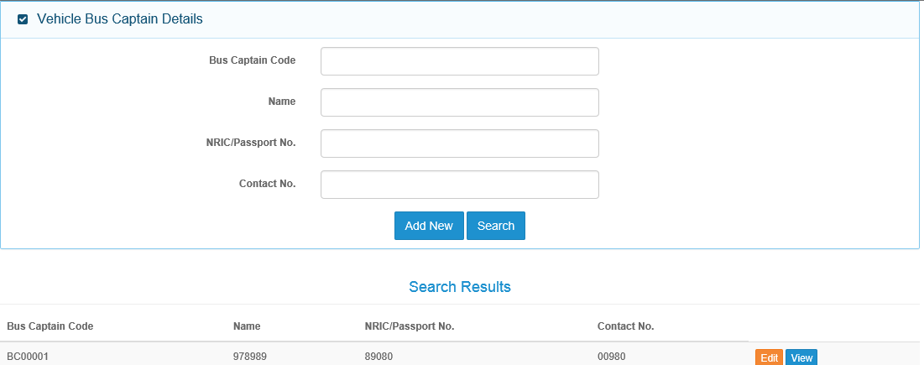

Action Column-

Assign

Have 3 columns –

Last Assignment Date, Type and Claim No.

Type = OD or TP

Replace with Department

Replace with User Group

Department

Claims Officer details

Save

This Claims Officer Duty Roster is for the Supervisor to assign new claims to Claims Officers and the criteria is whether the Bus Captain is at fault or not. Depending on this, then either an OD Claims Officer or OD and TP Claims Officers will be assigned to the case.

At Search option, unless specific search, all users with CO group will be displayed, showing the info.

Action button- Supervisor click Assign and system will update this Notification case to this Officer and update the Last Assignment Date and Type. Claim No. is not available at this stage and the info updated when Claims Officer logs in and create Claims registration

View button – click on this and Supervisor is able to view the Claims details of this case where the Claims Officer worked on. Make sure that upon completion of view, system brings Supervisor back to this screen

Save – click on Save and system updates the assignment details.